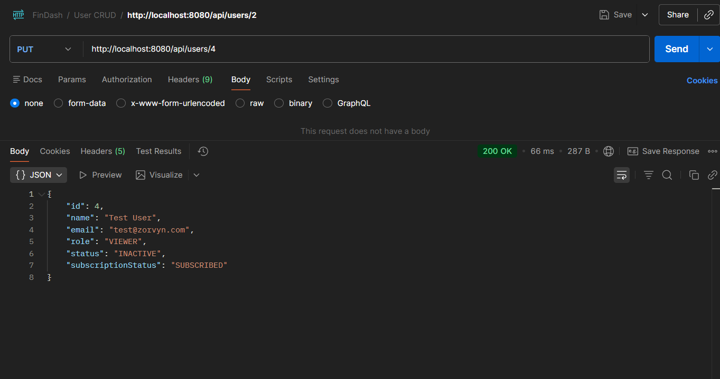
1. User CRUD
Method |  | URL
POST |  | http://localhost:8080/api/users  {  "name": "Test User",  "email": "test@zorvyn.com",  "role": "VIEWER",  "subscriptionStatus": "SUBSCRIBED",  "status": "ACTIVE"  }  Headers: X-User-Role: ADMIN  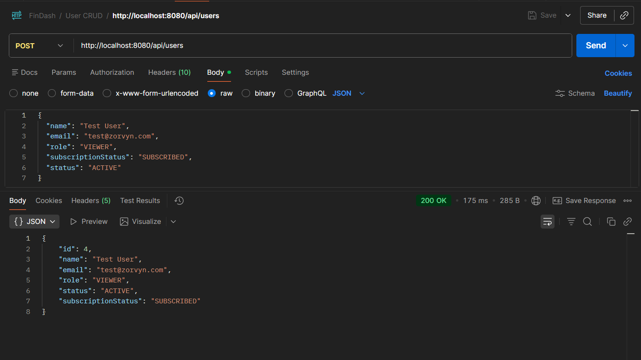
PUT |  | http://localhost:8080/api/users/2  {  "name": "Test User",  "email": "test@zorvyn.com",  "role": "VIEWER",  "subscriptionStatus": "SUBSCRIBED",  "status": "INACTIVE"  }  STATUS CHANGED TO INACTIVE
GET |  | 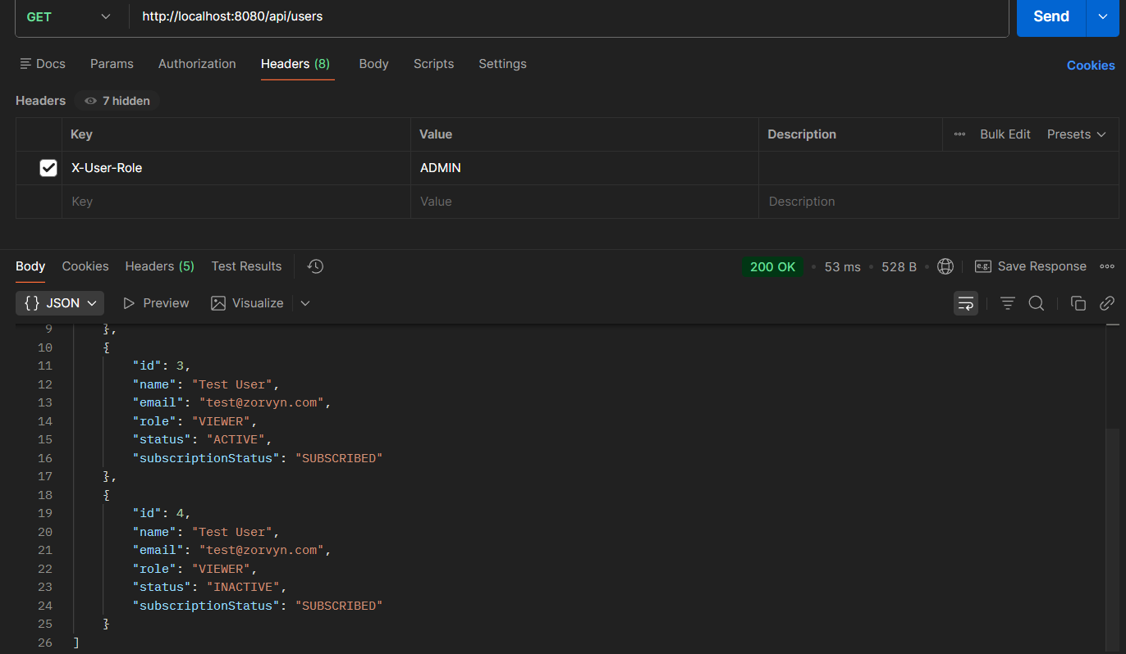  http://localhost:8080/api/users  Headers: X-User-Role: ADMIN
GET |  | http://localhost:8080/api/users  Headers: X-User-Role: VIEWER/ANALYST  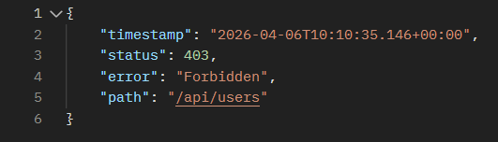
DELETE |  | 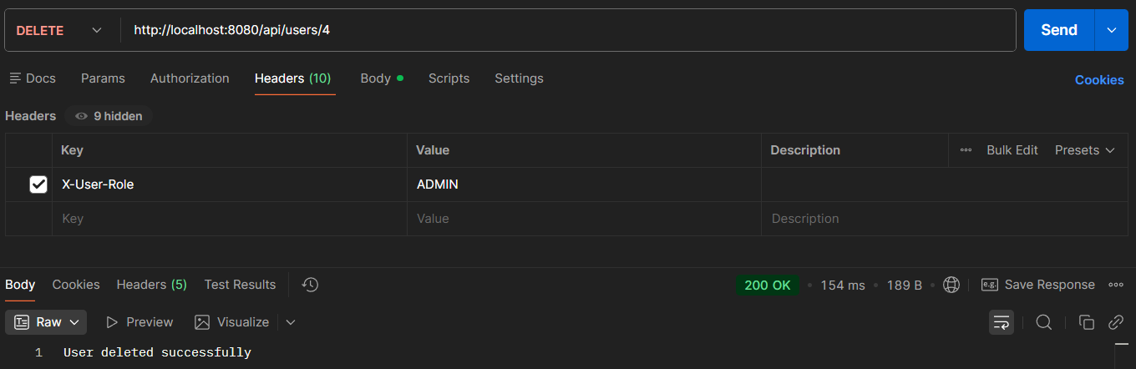  http://localhost:8080/api/users/4  Headers: X-User-Role: ADMIN
DELETE |  | http://localhost:8080/api/users/4  Headers: X-User-Role: VIEWER/ANALYST  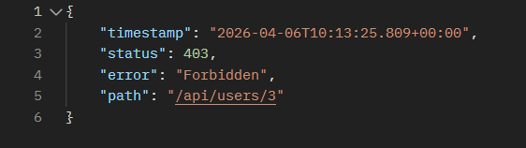

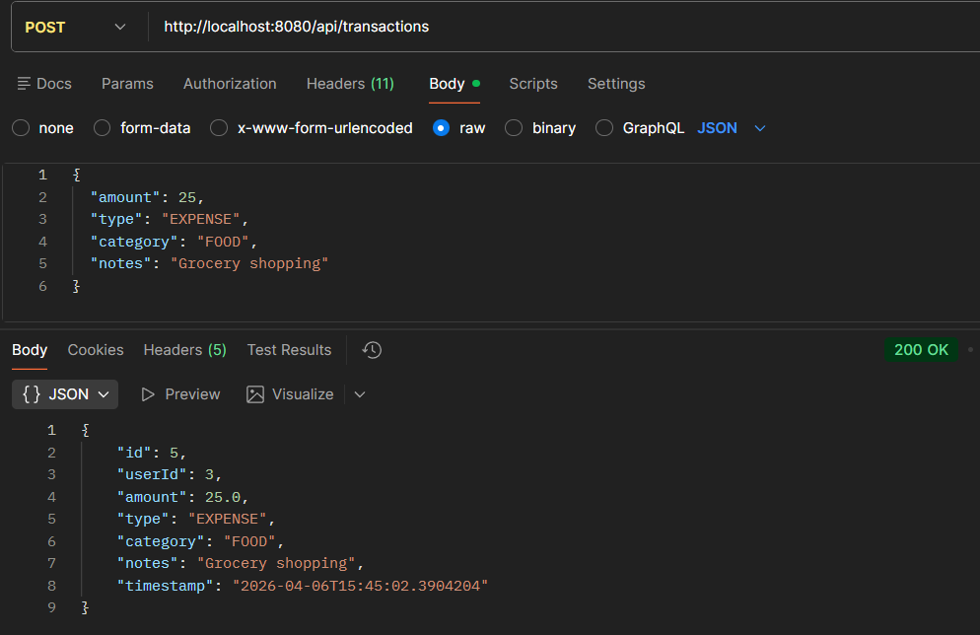
2. Transaction
Method | URL
POST | http://localhost:8080/api/transactions  {  "amount": 25,  "type": "EXPENSE",  "category": "FOOD",  "notes": "Grocery shopping"  }  
DELETE | http://localhost:8080/api/transactions/{trans-id}  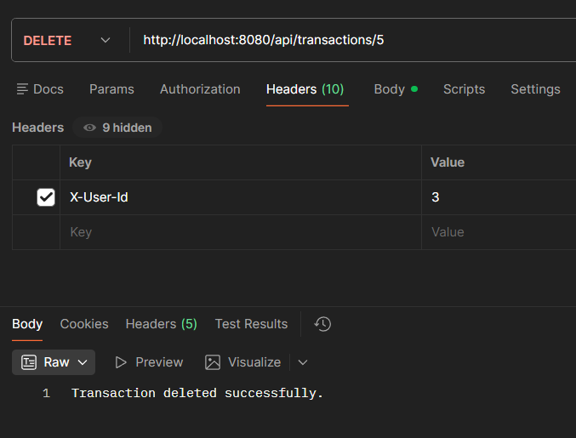

3. Dashboard
Method | URL
GET | http://localhost:8080/api/dashboard/summary  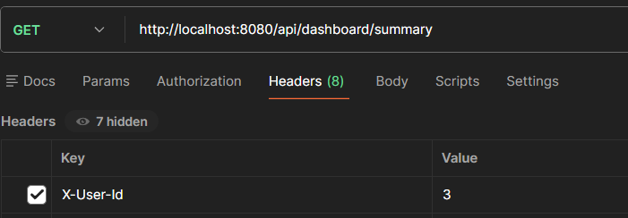
GET | {  "totalIncome": 0.0,  "totalExpenses": 526.5,  "netBalance": -526.5,  "categoryTotals": {  "FOOD": 526.5  },  "recentActivity": [  {  "id": 4,  "userId": 3,  "amount": 25.0,  "type": "EXPENSE",  "category": "FOOD",  "notes": "Grocery shopping",  "timestamp": "2026-04-06T15:15:14.593392"  },  {  "id": 3,  "userId": 3,  "amount": 250.75,  "type": "EXPENSE",  "category": "FOOD",  "notes": "Grocery shopping",  "timestamp": "2026-04-06T15:15:07.742124"  },  {  "id": 2,  "userId": 3,  "amount": 250.75,  "type": "EXPENSE",  "category": "FOOD",  "notes": "Grocery shopping",  "timestamp": "2026-04-06T15:14:59.451522"  }  ],  "wealthInsight": "Analyst Report: Your savings rate is below 20%. Recommended action: Review 'OTHERS' and 'BILLS' categories. Warning: Food & Dining is exceeding 15% of your income. Suggestion: Cook more at home this month. ",  "callAnalystEnabled": true  }  http://localhost:8080/api/dashboard/filter?from=2026-04-01&to=2026-04-30&category=FOOD&type=EXPENSE  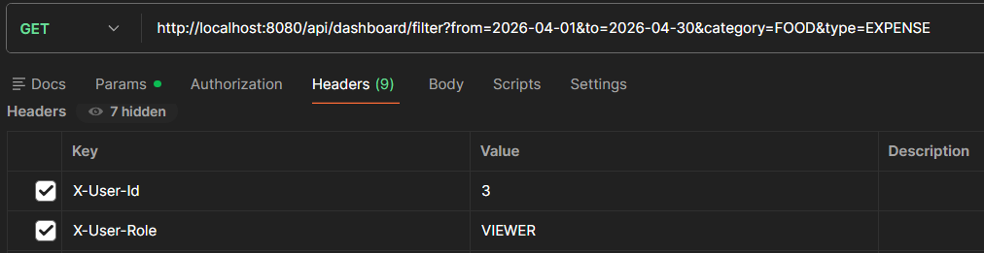

[
{
"id": 2,
"userId": 3,
"amount": 250.75,
"type": "EXPENSE",
"category": "FOOD",
"notes": "Grocery shopping",
"timestamp": "2026-04-06T15:14:59.451522"
},
{
"id": 3,
"userId": 3,
"amount": 250.75,
"type": "EXPENSE",
"category": "FOOD",
"notes": "Grocery shopping",
"timestamp": "2026-04-06T15:15:07.742124"
},
{
"id": 4,
"userId": 3,
"amount": 25.0,
"type": "EXPENSE",
"category": "FOOD",
"notes": "Grocery shopping",
"timestamp": "2026-04-06T15:15:14.593392"
}
]

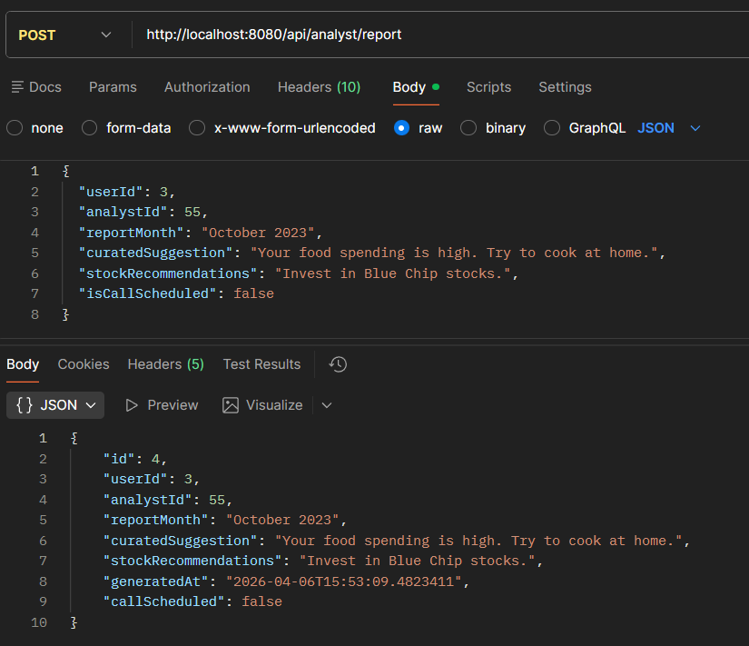
Analyst CRUD HEADER- Role - ANALYST
Method | URL
POST | http://localhost:8080/api/analyst/report
GET | 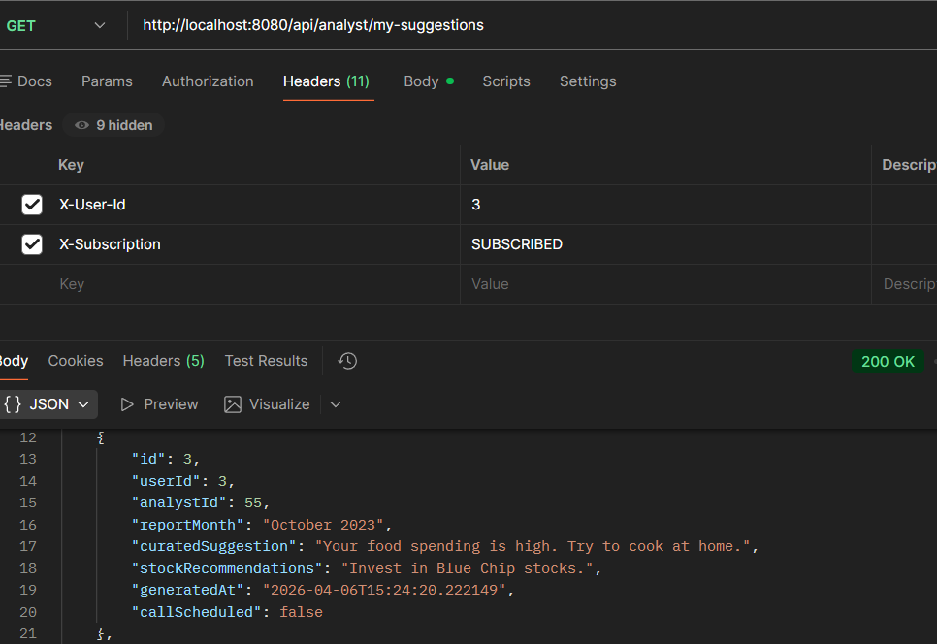  http://localhost:8080/api/analyst/my-suggestions
GET | 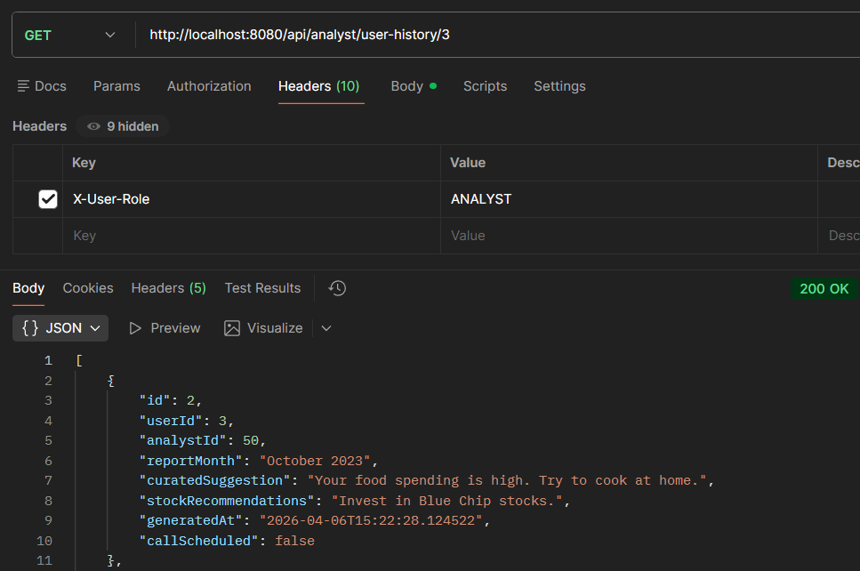  http://localhost:8080/api/analyst/user-history/3
Postman API Collection Link
https://web.postman.co/workspace/My-Workspace~83947b3e-9d08-451a-85ea-bd30f3796519/collection/35143465-47b0c68b-14f1-4dfb-9a1a-a3b608cd6662?action=share&source=copy-link&creator=35143465

